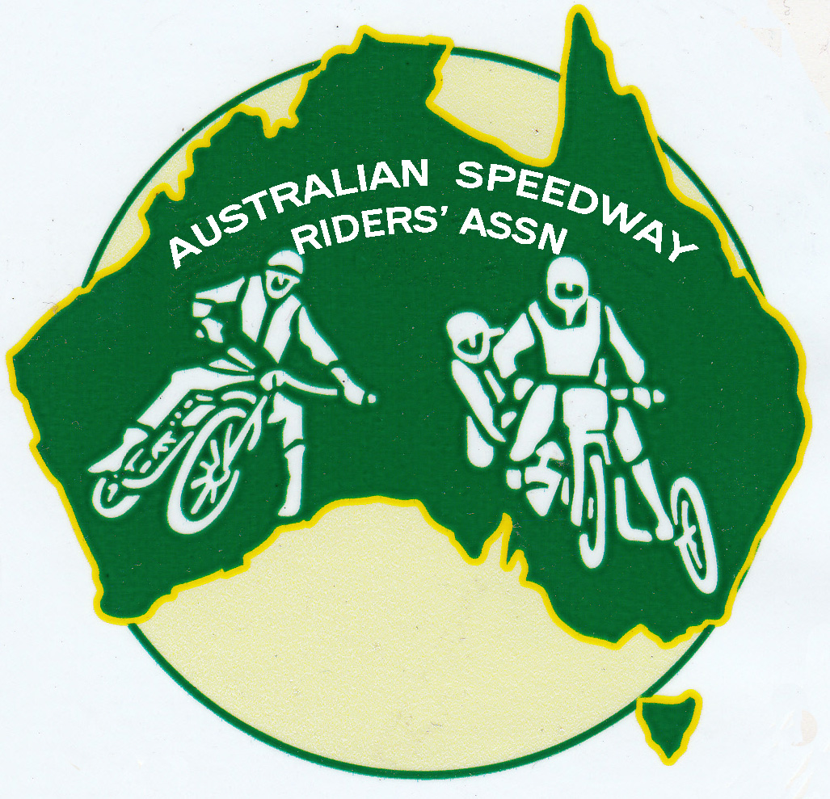
AUSTRALIAN SPEEDWAY RIDERS’ ASSOCIATION

MEMBERSHIP APPLICATION

FULL MEMBERSHIP (Speedway riders, sidecar riders and passengers)

- All retired riders and passengers are eligible for full membership regardless of duration of riding experience.

- All currently licensed riders and passengers are eligible for full membership.

I wish to apply for Full Membership of the ASRA of Australia

NAME ……………………………………………………………Date of Birth ……………………………….

ADDRESS …………………………………………………………………………………………..

TELEPHONE NO (……..) ……………………… MOBILE NO ………………………………………

EMAIL ADDRESS …………………………………………………………………………………………..

I first rode at a licensed speedway track in …………………………………………………………………..

At (track/s) …………………………………………………………………………………

I retired in …………………………….OR I am a current licence holder ……………………

ASSOCIATE MEMBERSHIP (eg promoters, officials, mechanics, photographers, rider’s relatives, enthusiasts, etc)

I wish to apply for Associate Membership of the ASRA of Australia

NAME ………………………………………………………………Date of Birth ……………………………….

ADDRESS …………………………………………………………………………………………..

TELEPHONE NO (……..) ……………………… MOBILE NO ………………………………………

EMAIL ADDRESS …………………………………………………………………………………………..

I was/am, associated with Speedway as a ……………………………………………………………………..

At (track/s) …………………………………………………………………………………

SIGNATURE …………………………….. ……….. DATE ………………………………………....

FULL AND ASSOCIATE MEMBERSHIP is $A25 per person

I enclose my annual Membership fee of $25 Cheque / Money Order

Payable to Australian Speedway Riders’ Association

Forward to Bill Powell – ASRA Treasurer, 50 Tuffy Avenue, Sans Souci NSW 2219

Contact details Phone - (02) 9583 2706 Email – bill.p133@live.com

